Assignment Week 4
Name: Son Cao (570135)
Group 10
Class ETI2VI-A2
Exercise 6: Retail Sales

Step 1: First Normal Form (1NF)
Rule (1NF)
- All attributes must be atomic (single value).
- No repeating groups or multi-valued attributes.
Issue
- The table has repeating products per order (e.g., order 3462 with 3 products).
- Fields like Total_sale, Sales_tax, Total_amount are derived (calculated values).
- Customer address is not atomic (street and number in same column).
Solution
- Split orders and products into Order and OrderLine (order details).
- Keep one row per product per order.
- Break customer address into separate fields if needed (Street, HouseNo).
- Remove calculated attributes (can be computed later).
Tables after 1NF
- CUSTOMER(Customer_ID, Name, Street, HouseNo, Phone)
- ORDER(Order_ID, Date, Customer_ID)
- ORDER_LINE(Order_ID, Product_ID, Quantity, UnitPrice)
- PRODUCT(Product_ID, Description, Dept_ID)
- DEPARTMENT(Dept_ID, DeptName, City)
Before (Unnormalized (raw SALES table):
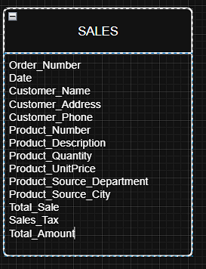

PRODUCT
Product_ID | Description | Dept_ID
203322 | Crockpot | 10
215099 | Multicooker | 10
220510 | Rice cooker | 10
445566 | Washing Mach. | 20
456789 | Iron | 20
324532 | Refrigerator | 20

AFTER (1NF) (Tables)
CUSTOMER
Customer_ID | Name | Street | HouseNo | Phone
1 | Antony Duncan | Main Street | 125 | 813-5834466
2 | Ray Curtis | North Blvd | 223 | 813-5468888
DEPARTMENT
Dept_ID | DeptName | City
10 | Kitchen | Utrecht
20 | Home Appliances | Amsterdam

ORDER
Order_ID | Date | Customer_ID | TotalSale | Tax | TotalAmount
3462 | 12/09/2015 | 1 | 605.00 | 97.00 | 702.00
3597 | 15/09/2015 | 2 | 2190.00 | 350.00 | 2540.00

ORDER_LINE
Order_ID | Product_ID | Quantity | UnitPrice
3462 | 203322 | 3 | 85.00
3462 | 215099 | 2 | 100.00
3462 | 220510 | 5 | 30.00
3597 | 445566 | 2 | 550.00
3597 | 456789 | 3 | 70.00
3597 | 324532 | 1 | 880.00

(Draw.io)
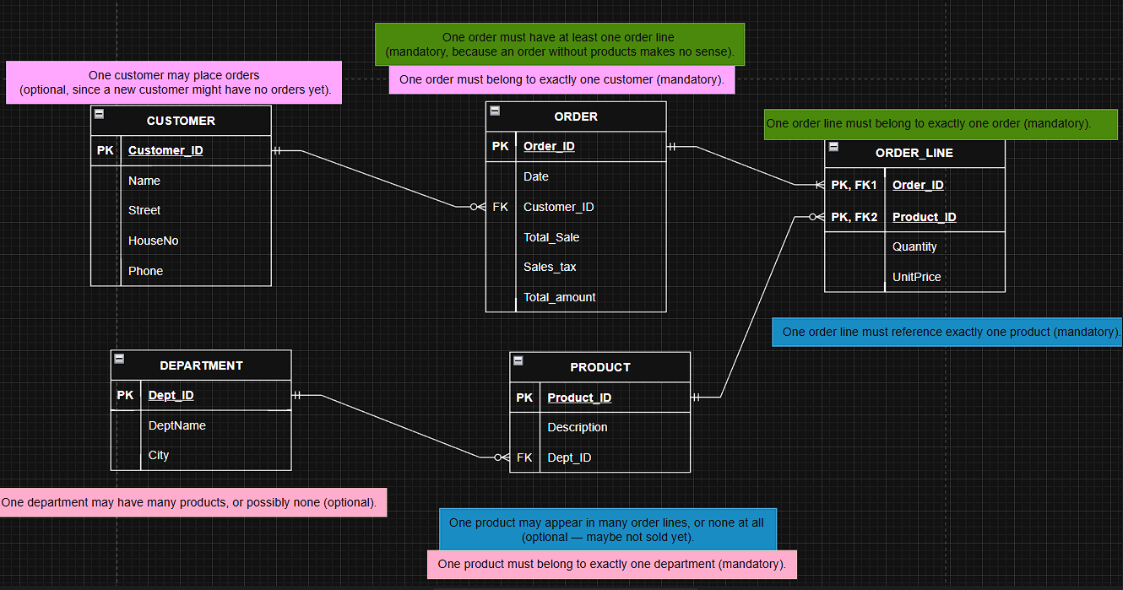
Step 2: Second Normal Form (2NF)
Rule (2NF)
- Table must be in 1NF.
- All non-key attributes must depend on the whole primary key (no partial dependency). That means: In a table with a composite key, every non-key attribute must depend on the whole key, not just part of it.
Issue
- In ORDER_LINE, UnitPrice depends only on Product_ID, not on the full key {Order_ID, Product_ID}.
- Keeping UnitPrice in ORDER_LINE causes redundancy.
Solution
- Move UnitPrice to the PRODUCT table.
- Keep only {Order_ID, Product_ID, Quantity} in ORDER_LINE.

(Tables) (remove partial dependency → move UnitPrice into PRODUCT)

ORDER_LINE
Order_ID | Product_ID | Quantity
3462 | 203322 | 3
3462 | 215099 | 2
3462 | 220510 | 5
3597 | 445566 | 2
3597 | 456789 | 3
3597 | 324532 | 1
PRODUCT
Product_ID | Description | UnitPrice | Dept_ID
203322 | Crockpot | 85.00 | 10
215099 | Multicooker | 100.00 | 10
220510 | Rice cooker | 30.00 | 10
445566 | Washing Mach. | 550.00 | 20
456789 | Iron | 70.00 | 20
324532 | Refrigerator | 880.00 | 20

(Draw.io)
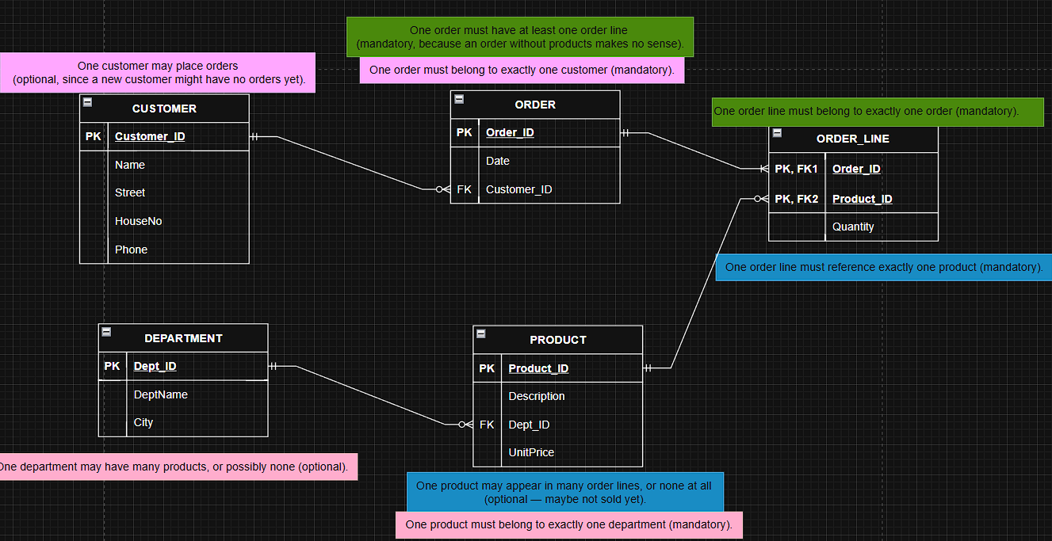
Step 3: Third Normal Form (3NF)
Rule (3NF)
- Table must be in 2NF.
- No transitive dependencies: non-key attributes cannot depend on other non-key attributes.
Issue
- In DEPARTMENT, City depends on Dept_ID, but if multiple departments share a city, we’ll repeat city names.
- If the City depends on DeptName (because each department name always corresponds to one city), then City is dependent on another non-key attribute, not directly on the PK (Dept_ID) => no transitive dependencies
Solution
- Create a CITY table.
- Let DEPARTMENT reference it by City_ID.
Final Tables (3NF)
- CUSTOMER(Customer_ID, Name, Street, HouseNo, Phone)
- ORDER(Order_ID, Date, Customer_ID)
- ORDER_LINE(Order_ID, Product_ID, Quantity)
- PRODUCT(Product_ID, Description, UnitPrice, Dept_ID)
- DEPARTMENT(Dept_ID, DeptName, City_ID)
- CITY(City_ID, CityName)
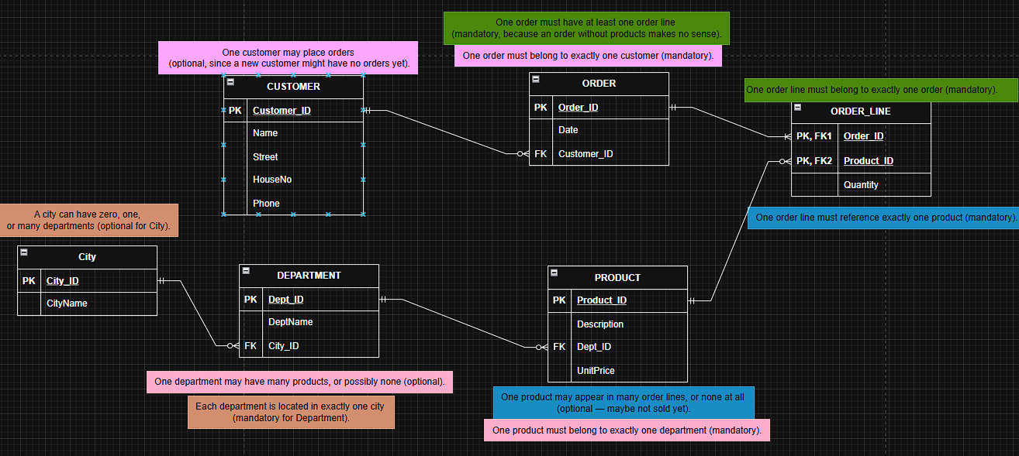
(Tables) (remove transitive dependency → City into separate table)
DEPARTMENT
Dept_ID | DeptName | City_ID
10 | Kitchen | 1
20 | Home Appliances | 2
CITY
City_ID | CityName
1 | Utrecht
2 | Amsterdam

